**Unit 3**　**What Would You Like?**

**Part A** (**3**)

词汇 积累练

一、开动脑筋，你来写。(20分)

1．　　D:\2012x\WORD\全练夹卷四年级英语上人教PEP版\YYF162.TIF　　　 2.　　

3．　　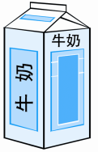 4.　　D:\2012x\WORD\全练夹卷四年级英语上人教PEP版\YYF120.TIF

语句 应用练

二、根据提示，完成句子。(30分)

1．你早餐想要吃些什么？

What would you like for________？

2．我想要吃两个鸡蛋。

I'd like two________.

3．多么丰盛的午餐啊！

What a________lunch!

4．我可以吃些面包吗？

Can I have some________？

5．我想要喝一杯水。

I'd like a glass of ________.

6．我想要喝些牛奶。

I'd like some ________．

情景 交际练

三、想一想，选一选。(30分)

(　　)1.当你想问别人想要吃什么时，你应说：________

A．What do you like? B．What would you like?

(　　)2.当别人为你提供你想要的食物时，你应说：________

A．Thank you. B．Here you are.

(　　)3.当你想说“我想要喝一杯果汁”时，你应说：________

A．I'd like a glass of juice. B．I'd like a big juice.

实践 运用练

四、你来当回小记者。(20分)

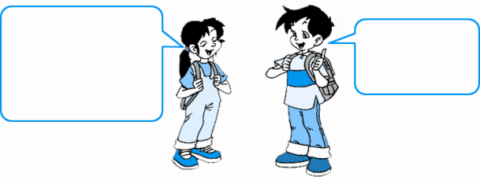

I'd like

some....

What would

you like for

dinner？

|  |  |  |  |
| --- | --- | --- | --- |
| Name | Jack | .... |  |
| rice | √ |  |  |
| noodles |  |  |  |
| beef |  |  |  |
| soup | √ |  |  |
| meat |  |  |  |
| fish | √ |  |  |
| chicken |  |  |  |
| vegetable | √ |  |  |

**答案全析全解**

一、1.bread　2.eggs　3.milk　4.water

二、1.breakfast　2.eggs　3.big　4.bread　5.water　6.milk

三、1.B　2.A　3.A

四、略。